* Q3:

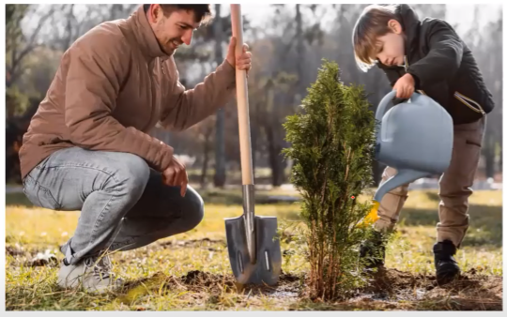

- Answer:

+ This picture is taken in a garden.

+ There are 2 people in the picture.

(Both of them are wearing winter clothes – Nếu muốn miêu tả quần áo của họ 1 lần)

+ On the left side, there is a man.

He is wearing a brown jacket.

And he is squatting down and holding a shovel.

+ Next to him, there is a little boy.

He is wearing a black jacket.

And he is watering the plant/holding a watering can.

+ In the background, I can see some trees.

* Q4:

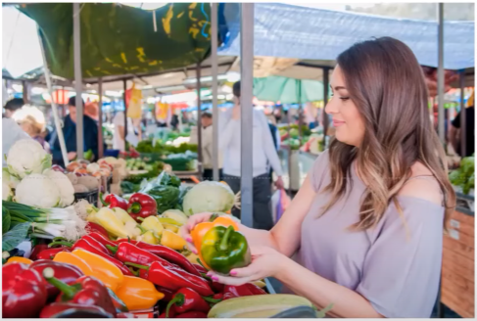

- Answer:

This picture is taken in the market.

There is a woman in the foreground.

She is holding some vegetables.

(She is holding some bell peppers).

She is wearing a purple blouse.

And she has long brown hair.

Behind her, there are some people buying products

* Q5:



- Answer:

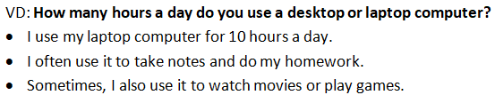

* Q6:

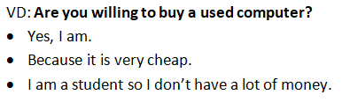

* Q7:

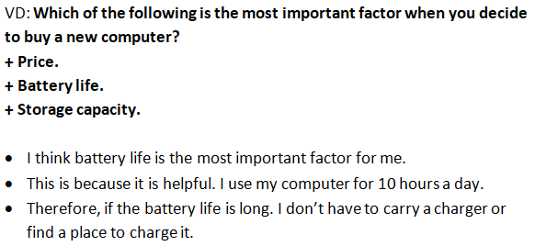

* Q8:



- Answer:

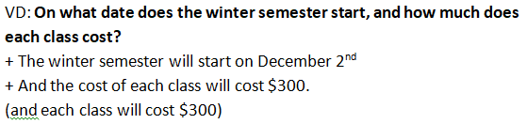

* Q9:

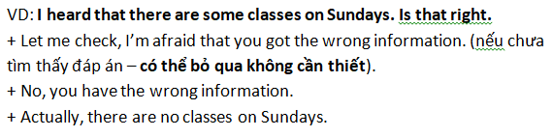

* Q10:

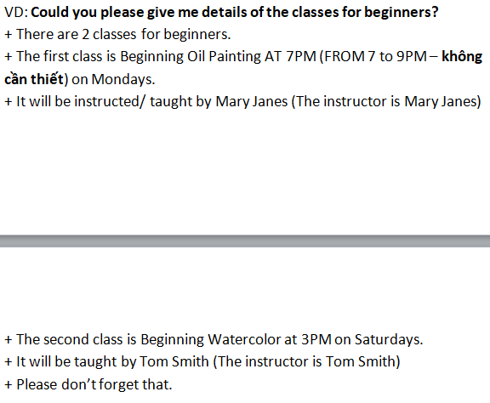

* Q11:

